

**October University for Modern Science and Arts (MSA)**

**Faculty of Computer Science**

Project Report

In fulfilment of the requirements of course CS283

Blood Emergency

By:

* Noha Ezzat
* Rokaia Emad
* Mariam Ziadi

Supervised by:

* Moemn Zaher
* Dr. Nehal Ali

# Introduction

# The project is to help people easily find the blood type they want anywhere and anytime. They could find it in a short time and know sufficient details about the hospitals that have this type. moreover, it shows accurate information rather than waiting them to answer a call. Also, it allows you to know the types available from each blood type. In addition, the website provides information about the process and answers all question that any patient would think about.

# Website objective

* Saving Time for searching about hospitals
* Give sufficient information about the process
* Quick access to hospitals in different areas
* Easy to use for all people

# Used tools and platforms

|  |  |
| --- | --- |
| Javascript |  |
| PHP |  |
| SQL |  |

# Main pages of the website

1. Home page

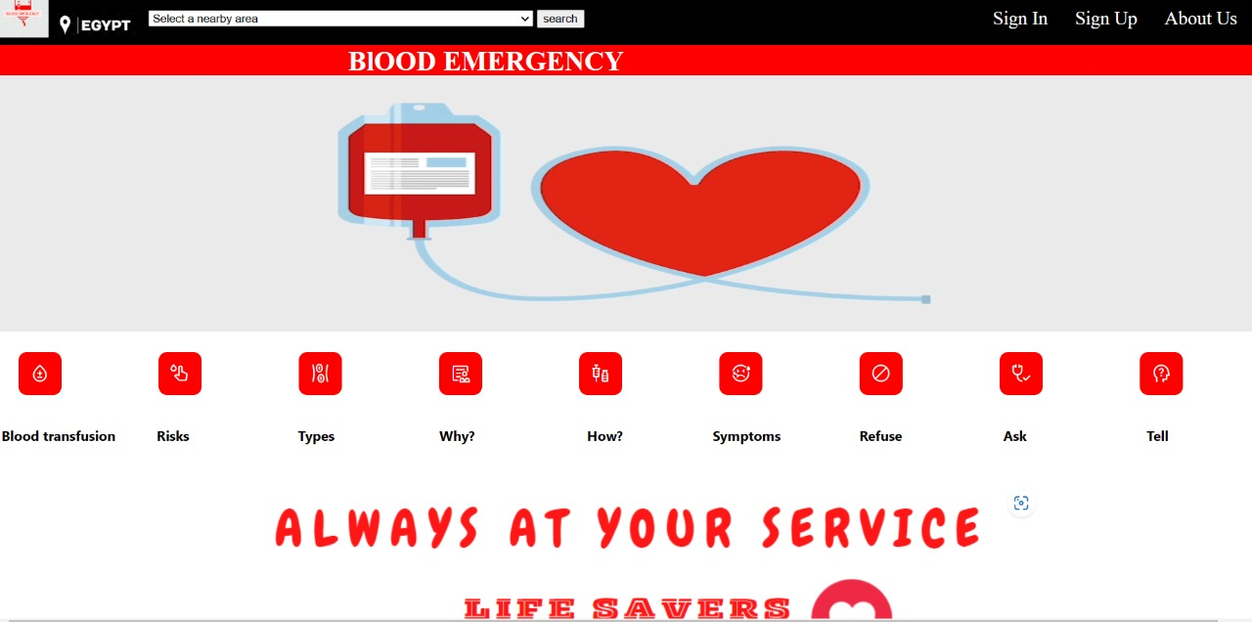

2-About Us

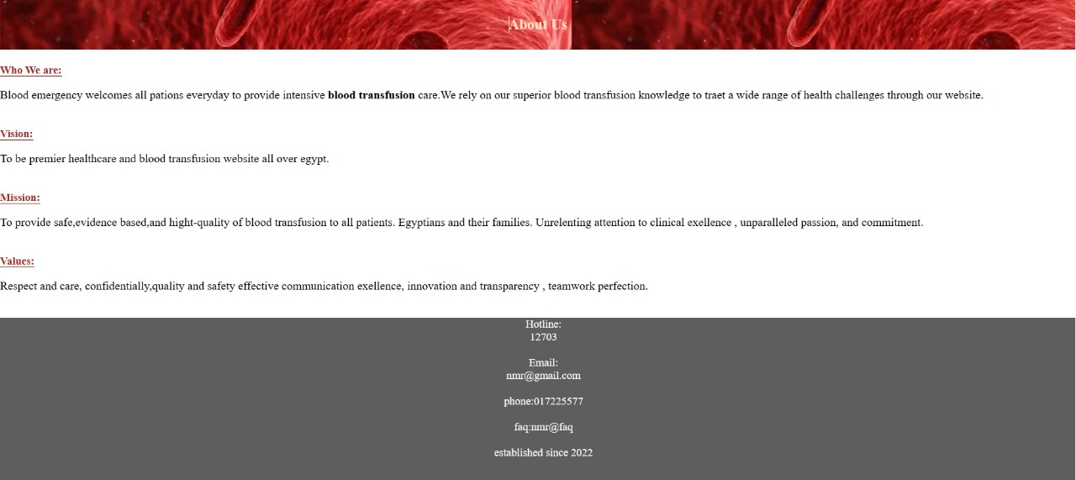

3- Sign Up

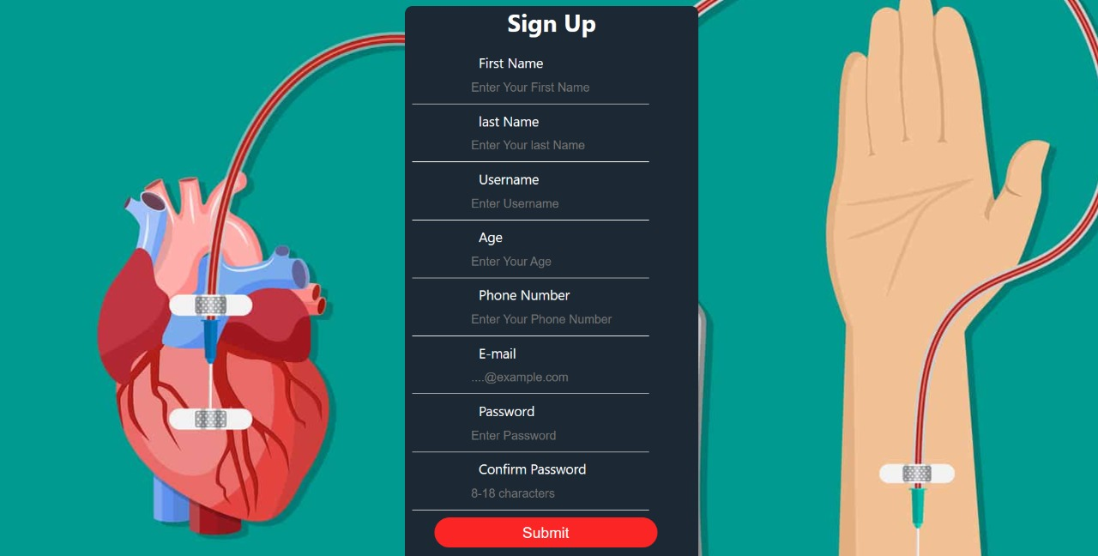

4-Sign in

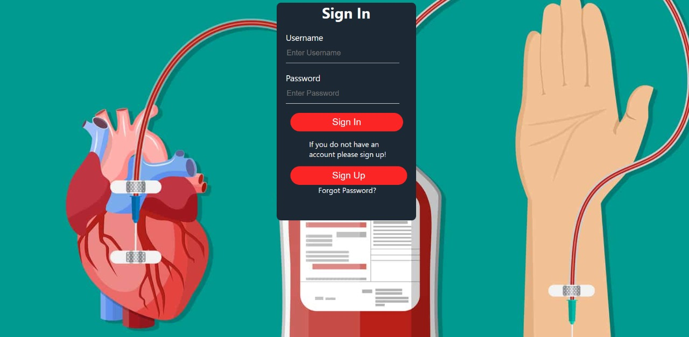

5-october Hospitals

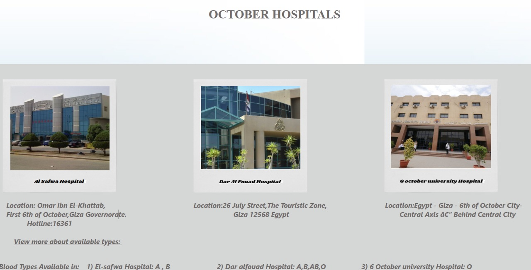

5-Mohandsein hospitals

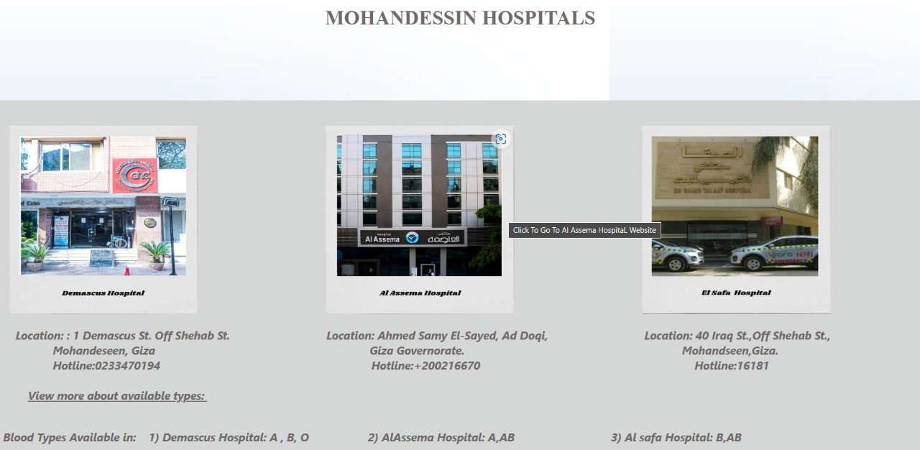

1. Fifth Settlement hospitals

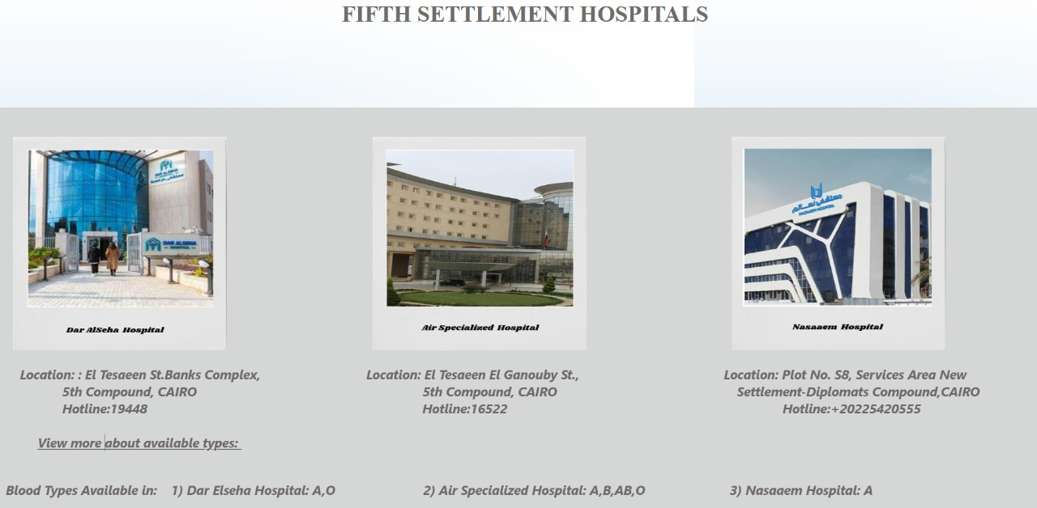

6-Genral info about blood transfusion

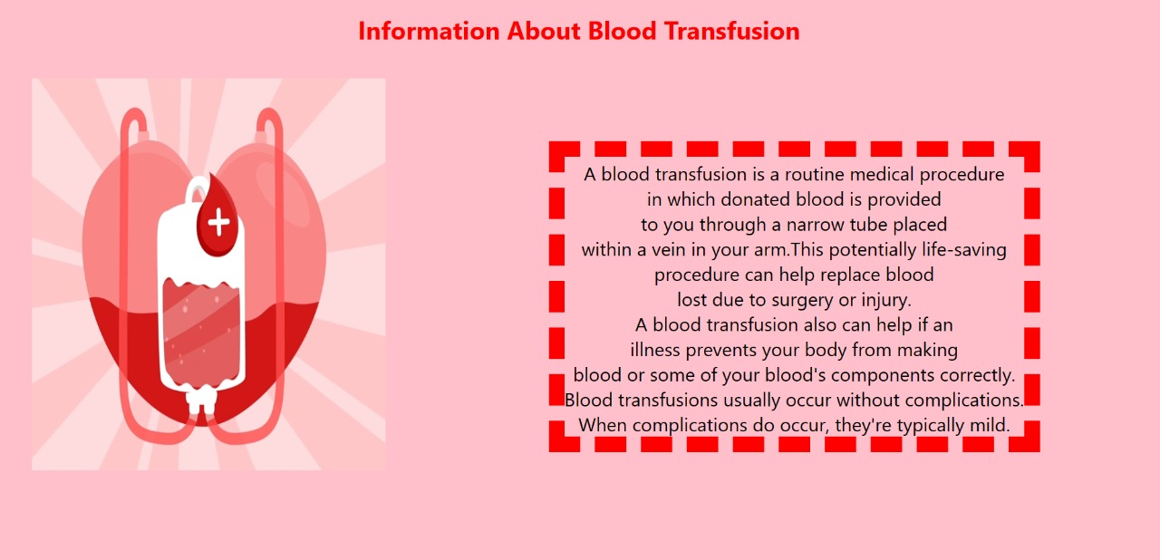

7-risks of blood transfusion

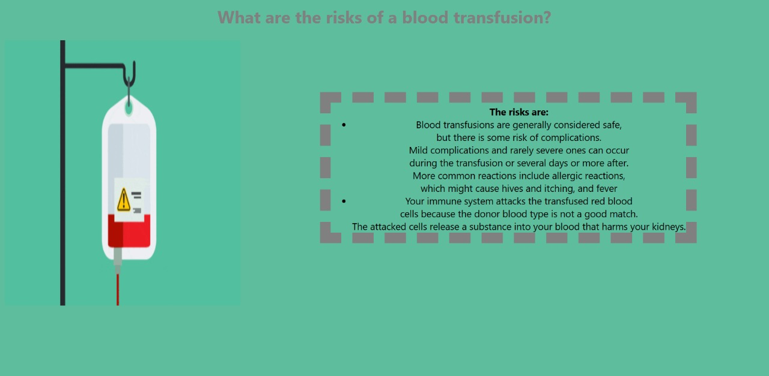

8-types of blood transfusion

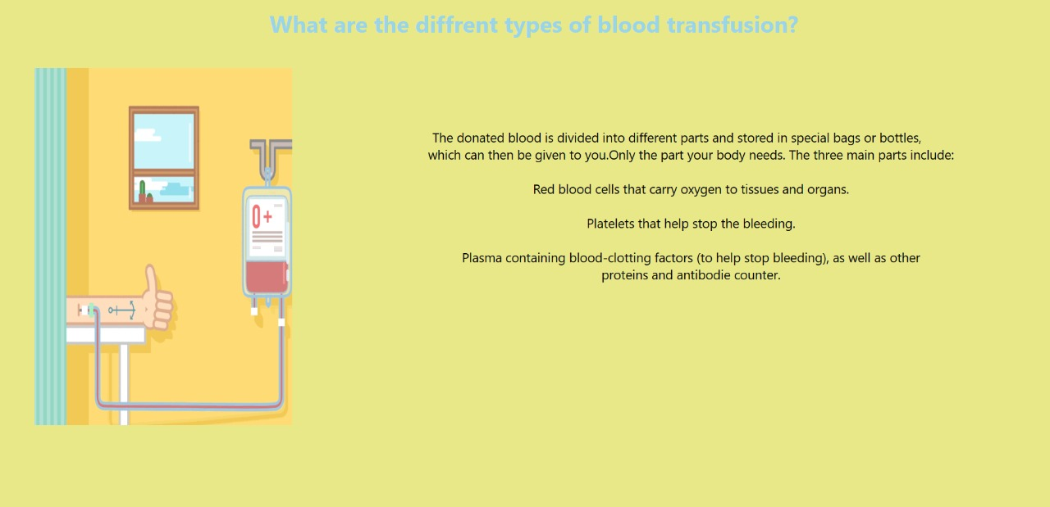

9-why would I need blood transfusion

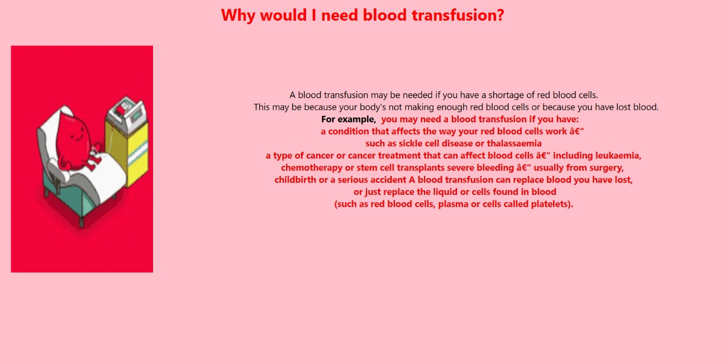

10-how is blood transfusion done

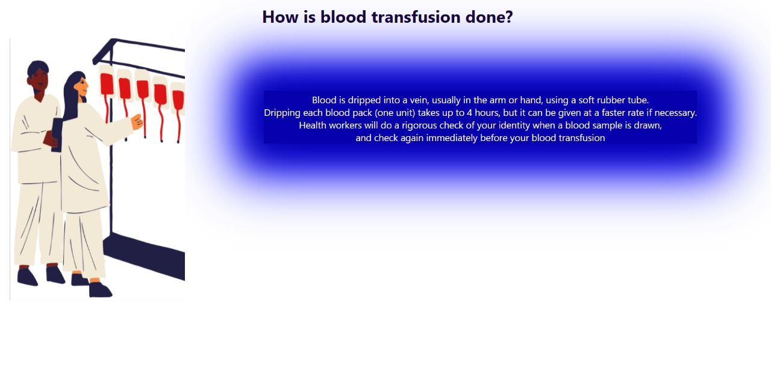

11-How I feel during blood transfusion

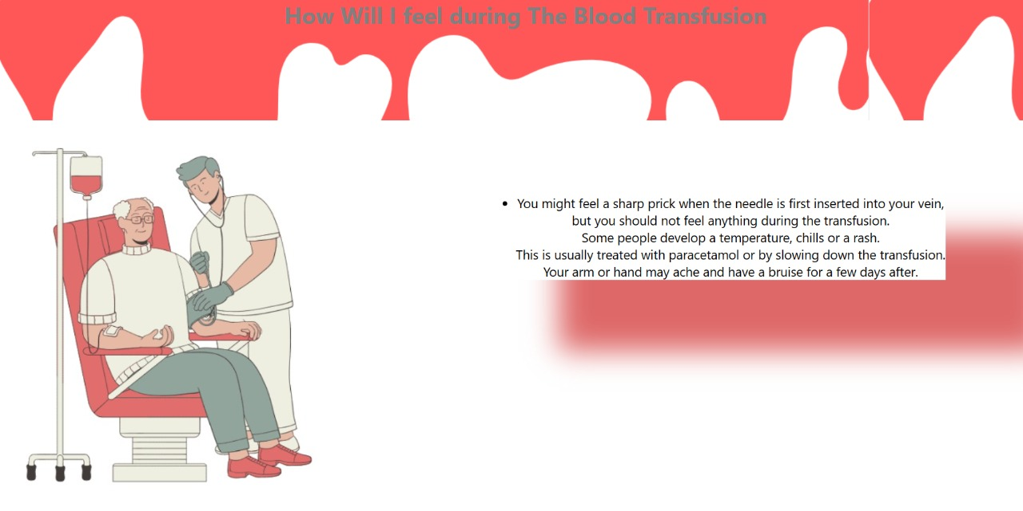

12-refuse blood transfusion

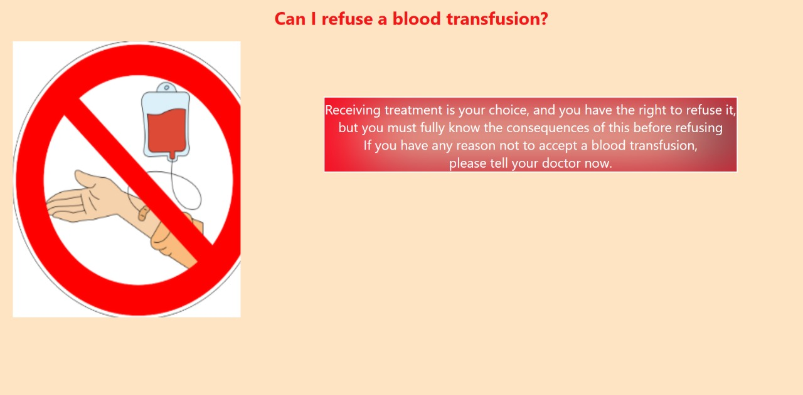

13-Ask your doctor

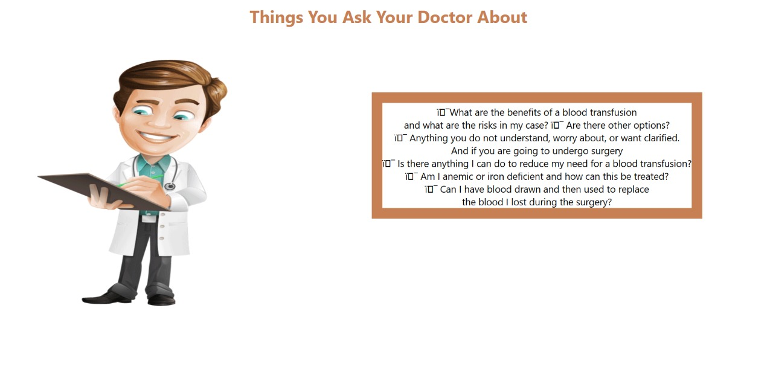

14-tell your doctor

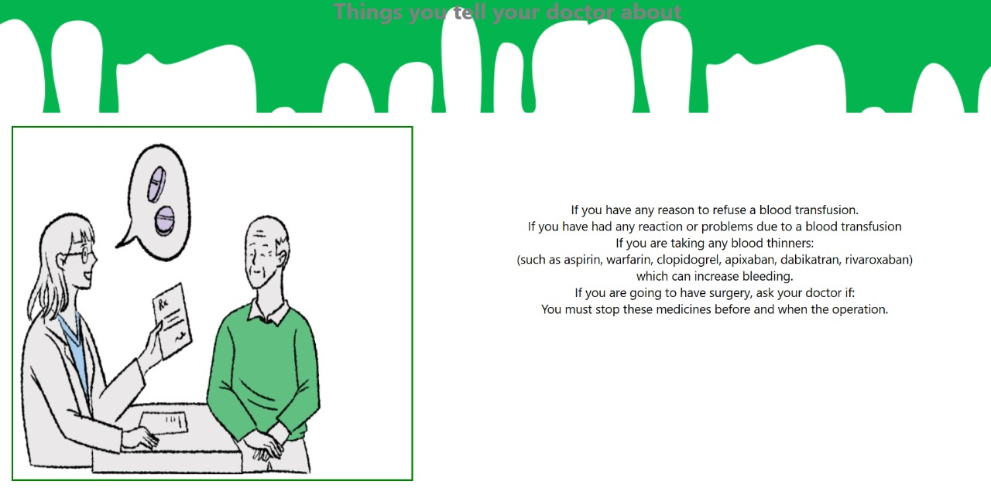

# Team members

1. Rokaia Emad: HTML,CSS,JAVASCRIPT,DATABASE,PHP
2. Noha Ezzat:HTML,CSS,PHP,JAVASCRIPT,DATABASE
3. Mariam Ziadi: HTML,CSS,JQUERY,DATABASE